­

|  |  |
| --- | --- |
| *Pacific Gas and Electric Company* | |
| Release 9.4 Installation Guide | |
|  |  |
|  |  |
| Project | ED AM/GIS |
|  |  |
| Prepared by | Roger Carribine |
| Date | 3/18/2015 |
| Version | 1.2 |
| Version Type | As-Built |

|  |  |  |  |
| --- | --- | --- | --- |
| Revision History | | | |
| Document # | Date | Author | Summary of Changes |
| 1.0 | 11th Feb 2015 | Roger/Ashish/Subhankar | Initial Document Creation |
| 1.1 | 9th Mar 2015 | Roger Carribine | As-built Updates |
| 1.2 | 18th Mar 2015 | Roger Carribine | Pre-prop As-built Updates |

# Introduction

## Purpose

This document is intended to detail the implementation and configuration steps required to implement Release 9.3.1B Installation Guide. This document describes the various configuration aspects required to complete any manual or automatic patch associated with this release. Each section in this document contains the steps required to patch the system in production.

## Terms Used

|  |  |
| --- | --- |
| OOTB | Out of the box. Unmodified from the commercial version. |
| TFS | Team Foundation Server |

## External Documents

Referenced are any external configuration documents or exports. These are documents that contain more detailed information about configuring a system or documents that can be loaded into an application to perform the configuration detailed in this document.

1. 9.4 circuit color scripts and documents
   1. \\sfetgis-nas01\sfgispoc_data\ApplicationDevelopment\IBM_Delivery\ReleaseInstructions\9.4\circuit_color

## List of Fixes

Below is the list of change requests detailing all fixes for the data model for this release:

|  |  |
| --- | --- |
| **Item Number** | **Title** |
| **19250** | Master TFS Data Model 9.4 |
| **15830** | Remove Transfomer Load related table |
| **13764** | New Valid Value for Deliver Pt Customer Type Domain - PAR #57054 - 82468 |
| **15898** | WP 27/28 Add COR and PTT to Joint Pole Members Domain |
| **16705** | DM CR for SF PAR 70704: Add "Iron" to Pole Material Domain |
| **16929** | PAR 70762 Add EPR-Hypalon to Conductor Insulation - UG Domain |
| **17102** | PAR 72519 - Add "CLO" to Joint Pole Members Domain |
| **17226** | PAR #69093 / #72919 - New Values for Street Light Wattage Domain |
| **17874** | PAR 74279 - Add New Value to Street Light Lumens Domain |
| **18305** | PAR 80735 - Add legacy primary UG conductor code to the “Conductor Code – UG” Domain |
| **18729** | PAR #83431 - New Value for Conductor Size Domain |
| **18848** | Add new values to Fill Type Domain |
| **19738** | Assign PGE_MAPOFFICE field modelname to DeviceGroup |
| [**19364**](http://edappgistfsprd1:8080/tfs/web/wi.aspx?pcguid=15e9a9d1-95cb-4dd0-abfe-5af14ae6201f&id=19364) | Height and Width attributes need to be visible on ConduitSystem:DuctBank |
| [**19418**](http://edappgistfsprd1:8080/tfs/web/wi.aspx?pcguid=15e9a9d1-95cb-4dd0-abfe-5af14ae6201f&id=19418) | Apply PGE Horizontal Alignment AU on 50 scale anno feature classes |
| [**19424**](http://edappgistfsprd1:8080/tfs/web/wi.aspx?pcguid=15e9a9d1-95cb-4dd0-abfe-5af14ae6201f&id=19424) | Changes in NetworkProtector feature class |
| [**19425**](http://edappgistfsprd1:8080/tfs/web/wi.aspx?pcguid=15e9a9d1-95cb-4dd0-abfe-5af14ae6201f&id=19425) | Add SAPEQUIPID and TEMPEQUIPID to Transformer |
| **19507** | Update Duct Use and Fill Type fields on Duct and DuctDefinition |
| **19522** | Update display properties on DuctDefinition table |
| **19360** | New leader line subtypes for cross sections and butterflys |
| **19607** | Update ArcFM Properties |
| **19654** | Add new validation rule definitions to the severity map table |
| **19858** | Update PGE_CIRCUITCOLOR table with new circuits |
| **19840** | Update Secondary UG labeltext field length |
| **19941** | Unversion the CommonFeaturesDataset dataset |

## Summary of Steps to Complete Install

Contents

1 Introduction 3

1.1 Purpose 3

1.2 Terms Used 3

1.3 External Documents 3

1.4 List of Fixes 4

1.5 Summary of Steps to Complete Install 5

2 Open a Database Connection in ArcCatalog 7

3 15830 - Remove Transfomer Load related table 8

4 13764 - New Valid Value for Deliver Pt Customer Type Domain - PAR #57054 – 82468 9

5 15898 - WP 27/28 Add COR and PTT to Joint Pole Members Domain 10

6 16705 - DM CR for SF PAR 70704: Add "Iron" to Pole Material Domain 11

7 16929 - PAR 70762 Add EPR-Hypalon to Conductor Insulation - UG Domain 12

8 17102 PAR 72519 - Add "CLO" to Joint Pole Members Domain 13

9 17226 PAR #69093 / #72919 - New Values for Street Light Wattage Domain 14

10 17874 PAR 74279 - Add New Value to Street Light Lumens Domain 15

11 18305 PAR 80735 - Add legacy primary UG conductor code to the “Conductor Code – UG” Domain 16

12 18729 PAR #83431 - New Value for Conductor Size Domain 17

13 19738 Assign PGE_MAPOFFICE field modelname 18

14 19364 Height and Width attributes need to be visible on ConduitSystem:DuctBank 19

15 19418 Apply PGE Horizontal Alignment AU on 50 scale anno feature classes 20

16 19424 Changes in NetworkProtector feature class 23

17 19479: Update UFM relationship labels 26

18 19507 Update Duct Use and Fill Type fields on Duct and DuctDefinition 28

19 19522 Update display properties on DuctDefinition table 31

20 19360: New leader line subtypes for cross sections and butterfly diagrams 33

21 19607: Update ArcFM Properties 38

22 19654: Add new validation rule definitions to severity map 39

23 19858: Update PGE_CIRCUITCOLOR Table with New Circuits 40

24 19840: Update Secondary UG Labeltext field length 41

25 19941: Unversion the CommonFeaturesDataset dataset 42

26 Data Model Version Table 44

27 Known Issues 45

# Open a Database Connection in ArcCatalog

1. Open ArcCatalog.
2. Within the Catalog Tree, expand “Database Connections” and open the active connection for this process. This is the connection that is referenced in the change request associated with this document (EDGIS<DB name in the format X#Y> )

# 15830 - Remove Transfomer Load related table

1. In the root level of the database, right click the TransformerLoad table and select Delete.  
   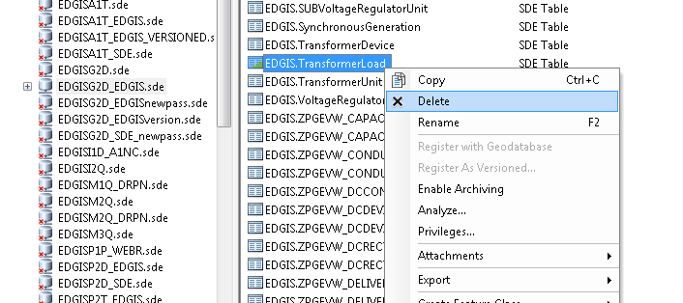

# 13764 - New Valid Value for Deliver Pt Customer Type Domain - PAR #57054 – 82468

1. Right click the database and select Properties.
2. In the Domains tab, scroll to the “Deliver Pt Customer Type” and enter the following new entry at the bottom of the list:

12/Fire Pump  
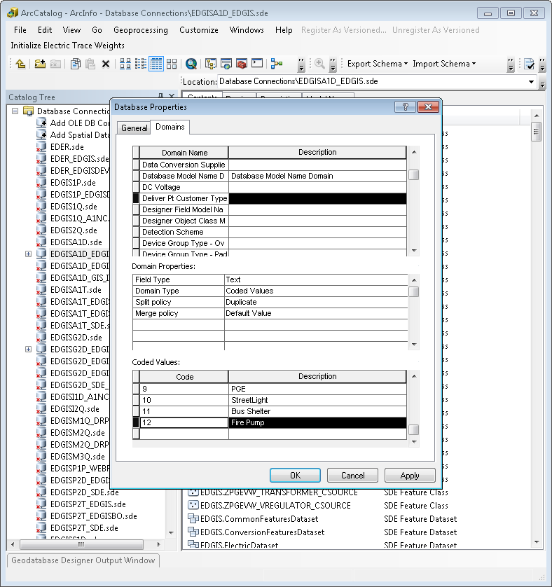

1. Click OK.

# 15898 - WP 27/28 Add COR and PTT to Joint Pole Members Domain

1. Right click the database and select Properties.
2. In the Domains tab, scroll to the Joint Pole Members domain.
3. Add the following code/value at the bottom of the list of values:  
   COR/City of Redding  
   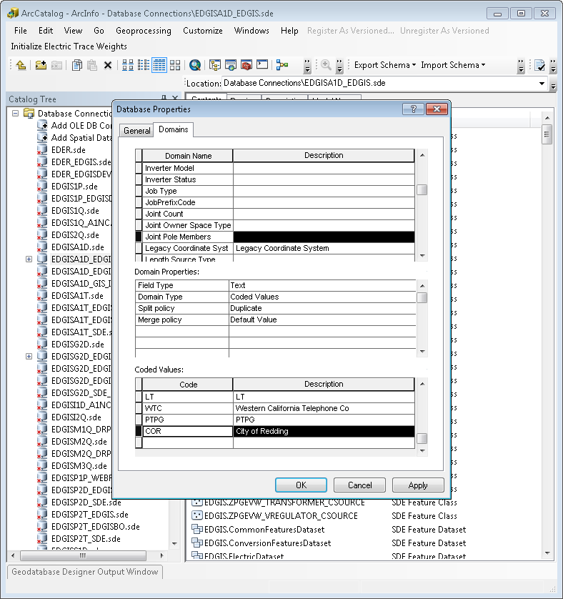
4. Click OK.

# 16705 - DM CR for SF PAR 70704: Add "Iron" to Pole Material Domain

1. Right click the database and select Properties.
2. In the Domains tab, scroll to the Pole Material domain.
3. Add the following code/value to the bottom of the lits:  
   IRON/IRON  
   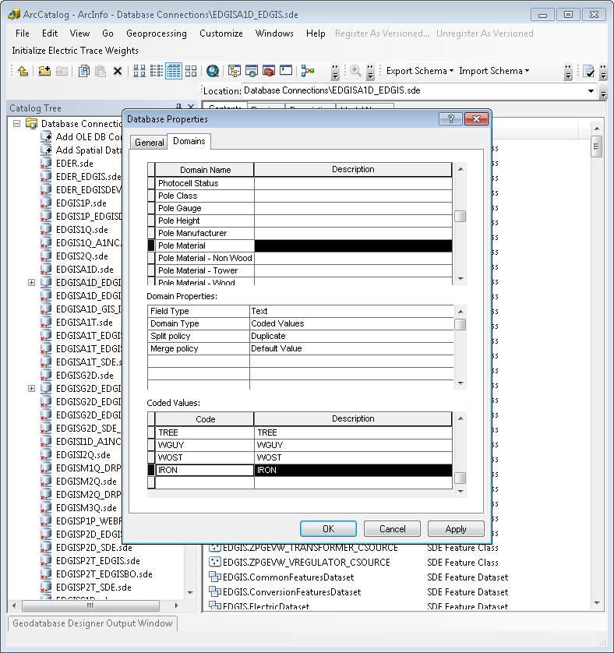
4. Select OK.

# 16929 - PAR 70762 Add EPR-Hypalon to Conductor Insulation - UG Domain

1. Right click the database and select Properties.
2. In the domains tab, scroll to the “Conductor Insulation – UG” domain and select it.
3. Add the following code/value to the bottom of the code/value list:  
   EPR-HYP/EPR-Hypalon  
   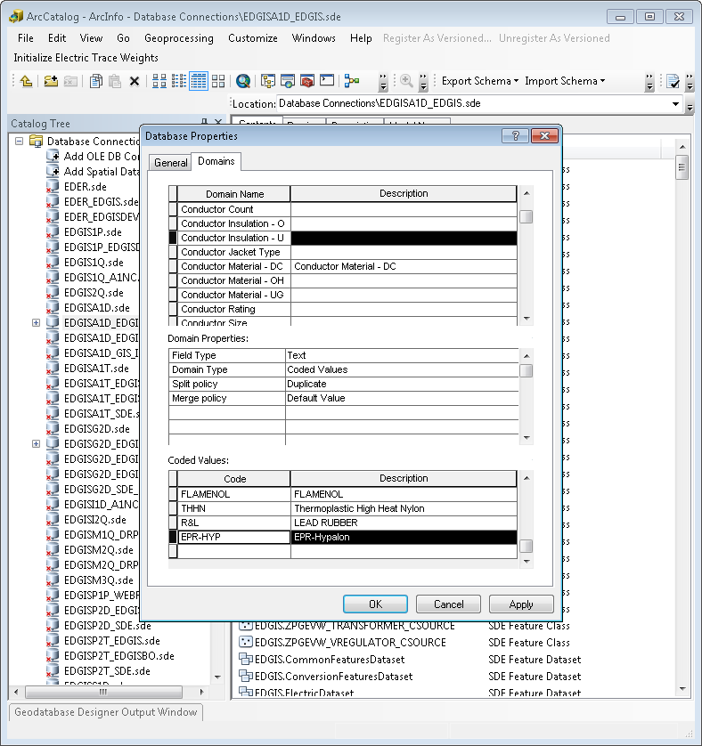
4. Click OK.

# 17102 PAR 72519 - Add "CLO" to Joint Pole Members Domain

1. Right click the database and select Properties.
2. In the Domains tab, scroll to the Joint Pole Members domain and select it.
3. Add the following code/value to the bottom of the list:  
   CLO/CLO
4. Select OK.
5. In ArcCatalog right click anywhere on the main toolbar and select Customize…
6. Select the commands tab
7. From the 'Developer Samples' commands category, add the 'Sort a domain' command to an existing toolbar or the context menu for a geodatabase. Note: If the category and/or Sort a domain command are not available, use ‘Add from File’ and load the DomainSort.dll from the ‘Sort_a_domain\Visual_Basic’ directory of the release folder
8. Use ArcCatalog to browse to the EDER database to sort a domain from.
9. Click on the command to bring up the dialog, and make choose below parameters for the sort.

Available Domains: - Joint Pole Members

Sort Type: - Ascending

Sort Item:- Description

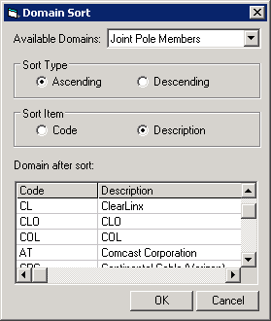

1. Click on Ok.

# 17226 PAR #69093 / #72919 - New Values for Street Light Wattage Domain

1. Right click the database and select Properties.
2. In the Domains tab, scroll to the Street Light Wattage domain and select it.
3. Add the following codes/values to the bottom of the list:  
   25/25 W

30/30 W

1. Select OK.

# 17874 PAR 74279 - Add New Value to Street Light Lumens Domain

1. Right click the database and select Properties.
2. In the Domains tab, scroll to the Street Light Lumens domain and select it.
3. Add the following code/value to the bottom of the list:  
   10000/10000L
4. Select OK.

# 18305 PAR 80735 - Add legacy primary UG conductor code to the “Conductor Code – UG” Domain

1. Right click the database and select Properties.
2. In the Domains tab, scroll to the Conductor Code - UG domain and select it.
3. Add the following code/value to the bottom of the list:  
   Code: 265

Value: 265 - al epr-conc-encap pe 15 kV {2}

1. Select OK.
2. In ArcCatalog right click anywhere on the main toolbar and select Customize…
3. Select the commands tab
4. From the 'Developer Samples' commands category, add the 'Sort a domain' command to an existing toolbar or the context menu for a geodatabase. Note: If the category and/or Sort a domain command are not available, use ‘Add from File’ and load the DomainSort.dll from the ‘Sort_a_domain\Visual_Basic’ directory of the release folder
5. Use ArcCatalog to browse to the EDER database to sort a domain from.
6. Click on the command to bring up the dialog, and make choose below parameters for the sort.

Available Domains: - Conductor Code - UG

Sort Type: Ascending

Sort Item: Code

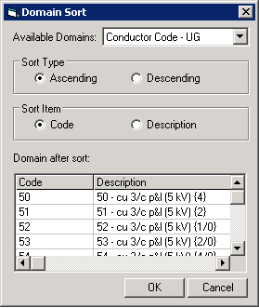

1. Click on Ok.

# 18729 PAR #83431 - New Value for Conductor Size Domain

1. Right click the database and select Properties.
2. In the Domains tab, scroll to the Conductor Size domain and select it.
3. Add the following code/value to the bottom of the list:  
   2000/2000
4. Select OK.

# 19738 Assign PGE_MAPOFFICE field modelname

1. In the ElectricDataset, right click the DeviceGroup feature class and select ArcFM Properties Manager.
2. Select the Field Model Names tab.
3. Scroll to the MAPOFFICE field and select it.
4. Assign the PGE_MAPOFFICE field model name to the field.

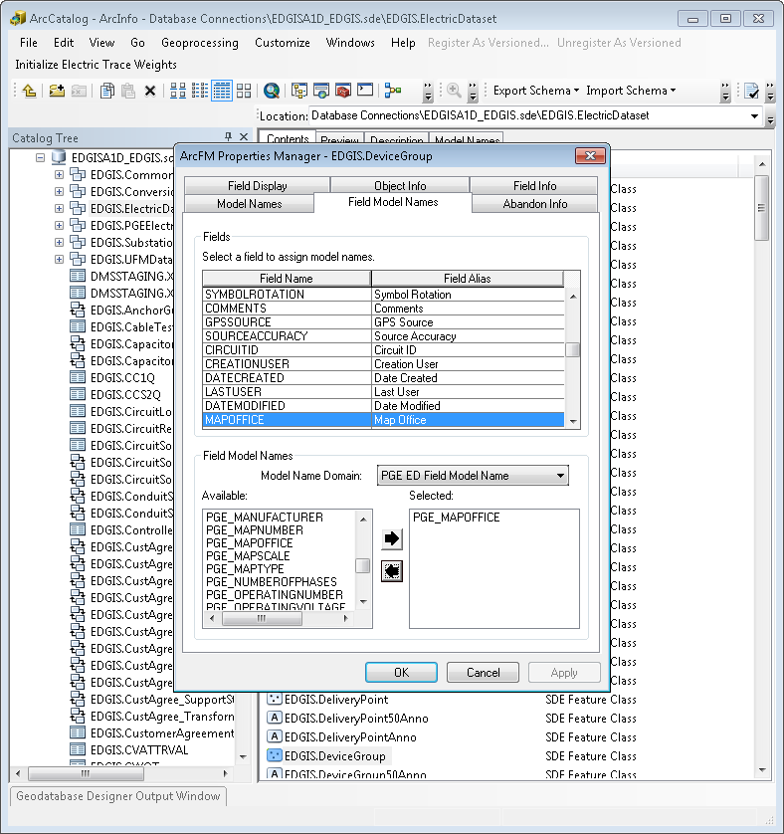

1. Repeat steps 1-4 for the following feature classes:

* EDGIS.PadmountStructure
* EDGIS.SubsurfaceStructure
* EDGIS.SupportStructure
* EDGIS.Substation

# 19364 Height and Width attributes need to be visible on ConduitSystem:DuctBank

1. In the Electric Dataset, right click on ConduitSystem and select ArcFM Properties Manager.
2. Select the Field Info tab.
3. Select Duct Bank for the subtype.
4. Locate the HEIGHT field and set Visible=Yes.
5. Locate the WIDTH field and set Visible=Yes.  
   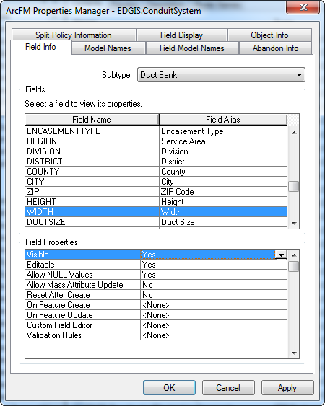
6. Click OK.

# 19418 Apply PGE Horizontal Alignment AU on 50 scale anno feature classes

1. In the ElectricDataset, right click the CapacitorBank50Anno feature class and select ArcFM Properties Manager.
2. In the Object Info tab, select the On Feature Create dropdown and select <Multiple>.  
   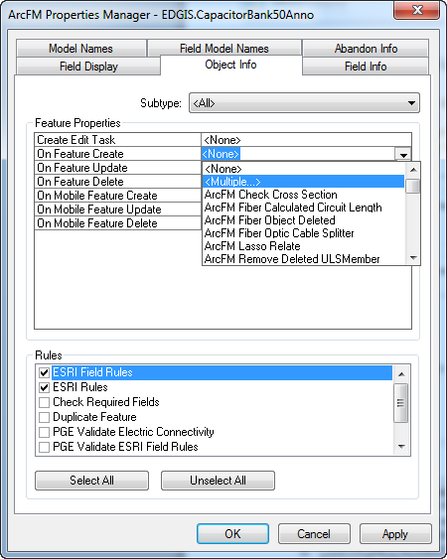
3. Assign the PGE Annotation Horizontal Alignment AU and click OK.  
   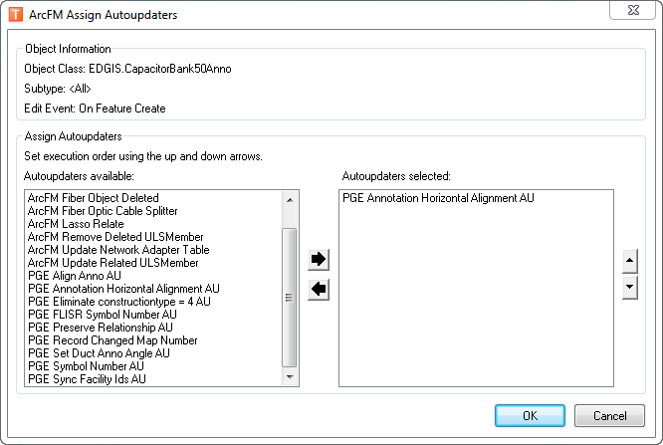
4. Select the On Feature Update dropdown and select <Multiple>.
5. Assign the PGE Annotation Horizontal Alignment AU and click OK.
6. Repeat the above steps for each of these feature classes
   1. CONDUITSYSTEM50ANNO
   2. CUSTAGREENUMBER50ANNO
   3. DCCONDUCTOR50ANNO
   4. DCDEVICE50ANNO
   5. DCRECTIFIER50ANNO
   6. DEACTIVATEDELECLINESEG50ANNO
   7. DELIVERYPOINT50ANNO
   8. DEVICEGROUP50ANNO
   9. DYNPROTDEVICE50ANNO
   10. FAULTINDICATOR50ANNO
   11. FUSE50ANNO
   12. JOBNUMBER50ANNO
   13. NETWORKPROTECTOR50ANNO
   14. NEUTRALCONDUCTOR50ANNO
   15. PRIMARYGENERATION50ANNO
   16. PRIOHCONDUCTOR50ANNO
   17. PRIUGCONDUCTOR50ANNO
   18. SECOHCONDUCTOR50ANNO
   19. SECONDARYGENERATION50ANNO
   20. SECUGCONDUCTOR50ANNO
   21. STEPDOWN50ANNO
   22. STREETLIGHT50ANNO
   23. SUBSTATION50ANNO
   24. SUBSURFACESTRUCTURE50ANNO
   25. SUPPORTSTRUCTURE50ANNO
   26. SWITCH50ANNO
   27. TRANSFORMER50ANNO
   28. ULSPRIUGCONDUCTOR50ANNO
   29. VOLTAGEREGULATOR50ANNO
   30. VAULTPOLY50ANNO
   31. DISTBUSBAR50ANNO

# 19424 Changes in NetworkProtector feature class

1. In the ElectricDataset, double click the NetworkProtector feature class.
2. Select the Fields tab.
3. Highlight the TRANSFORMERGUID field and press DELETE on your keyboard to delete the field.  
   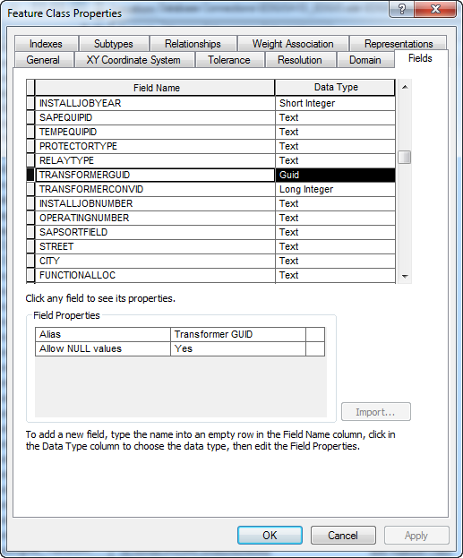
4. Highlight the TRANSFORMERCONVID field and press DELETE on your keyboard to delete the field.
5. Add the following new fields by scrolling to the bottom of the Fields list and typing in the details for the fields:
   1. Name: GEMSDISTMAPNUM
      1. Type: Text
      2. Alias: MET Distribution Map #
      3. Allow NULL Values: Yes
      4. Length: 10
   2. Name: GEMSCIRCUITMAPNUM
      1. Type: Text
      2. Alias: MET Circuit Map #
      3. Allow NULL Values: Yes
      4. Length: 10
   3. Name: GEMSOTHERMAPNUM
      1. Type: Text
      2. Alias: MET Other Map #
      3. Allow NULL Values: Yes
      4. Length: 10
      5. Length: 10  
         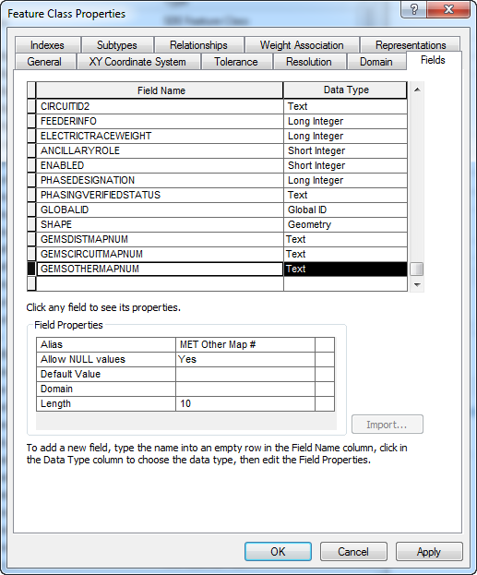
6. Click OK.

# 19479: Update UFM relationship labels

1. Get exclusive access of EDGIS
2. At the root node, navigate to EDGIS.ConduitSystem_DuctBank, right click on it. Click “Delete”. Click “Yes”.
3. Right click on **root node**. Select **New** 🡪 **Relationship Class**
4. Fill the necessary fields as give below:

(Root)

EDGIS.ConduitSystem_DuctBank

Forward Label: Duct Bank

Backward Label: Conduit

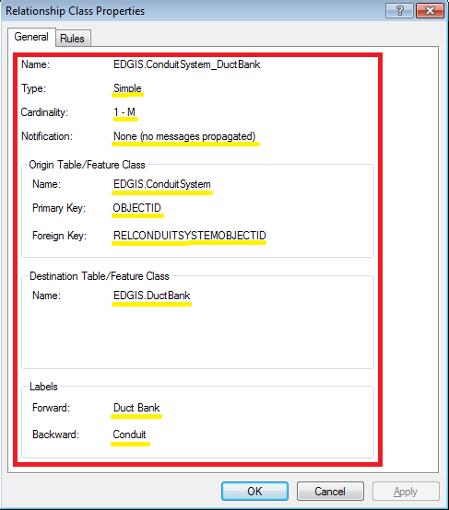

1. Go to EDGIS.UFMDataset, navigate to EDGIS.DuctAnnoRel, right click on it. Click “Delete”. Click “Yes”.
2. Right click on **UFMDataset**. Select **New** 🡪 **Relationship Class**
3. Fill the necessary fields as give below:

(UFM dataset)

EDGIS.DuctAnnoRel

Forward Label: Duct Annotation

Backward Label: Duct

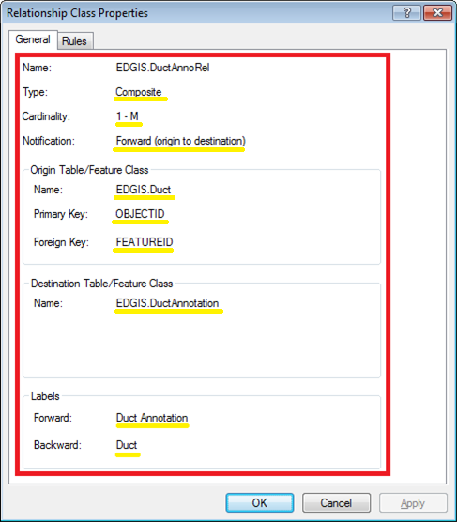

# 19507 Update Duct Use and Fill Type fields on Duct and DuctDefinition

1. Open the target database, right click it, and select Properties.
2. In the Domains tab, scroll to the DuctUseCondition domain and select it.
3. Change the following code descriptions:
   1. Modify code “DE”’s description to “Dead End”
   2. Modify code “P”’s description to “Plugged”  
      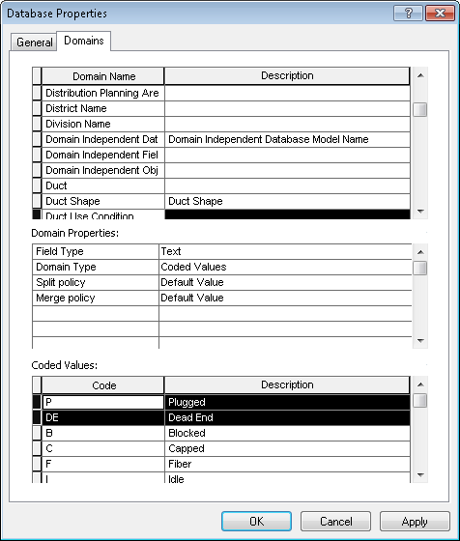
4. Add the following new code/value pair at the end of the list:
   1. “DA”/”Deact”
5. Remove the following code/value pairs:
   1. “T”/”Tel”
   2. “F”/”Fiber” values
6. Press Apply and OK.
7. In the UFMDataset, double click Duct.
8. In the Fields tab, select the FILLTYPE field and delete it.  
   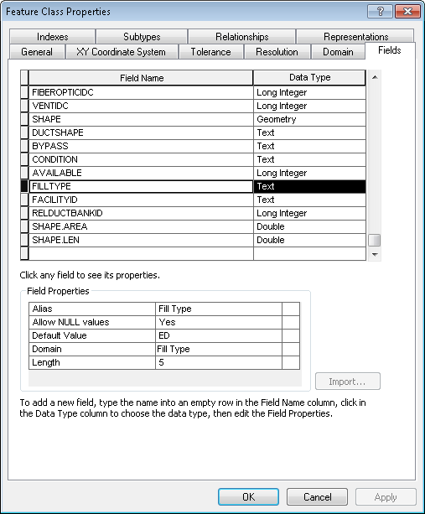
9. Add the following new fields at the end of the list with the following common properties:
   1. Field name (field alias):
      1. TELCOIDC (Telco Indicator)
      2. ELECTRICTRANSMISSIONIDC (Elec Transmission Indicator)
      3. GASLINEIDC (Gas Line Indicator)
      4. SCADAIDC (SCADA Indicator)
      5. SFDTIDC (SF Dept. Technology Indicator)
      6. MUNICABLEIDC (Muni Cable Indicator)
      7. TEMPERATUREIDC (Temperature Indicator)
      8. MISCIDC1 (Future 1 Indicator)
      9. MISCIDC2 (Future 2 Indicator)
      10. MISCIDC3 (Future 3 Indicator)
   2. Type: Long Int
   3. Allow Nulls: Yes
   4. Default: 0
   5. Domain: Yes No Numeric
   6. Precision: 10  
      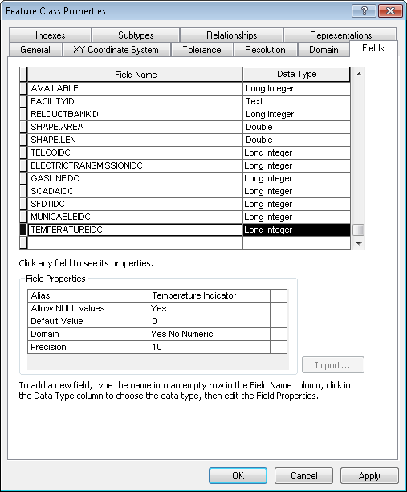
10. Repeat steps 8 and 9 for the EDGIS.DuctDefinition table.

# 19522 Update display properties on DuctDefinition table

1. In the root of the database, select the DuctDefinition table.
2. Click the Unregister As Versioned button (add this button to the toolbar if it is not there already).  
   
3. Right click the DuctDefinition table and select ArcFM Properties Manager.
4. In the Field Info tab, edit the below for both the Conduit and Duct Bank subtypes..
5. Modify the following field info ArcFM properties
   1. Object ID - change to not visible  
      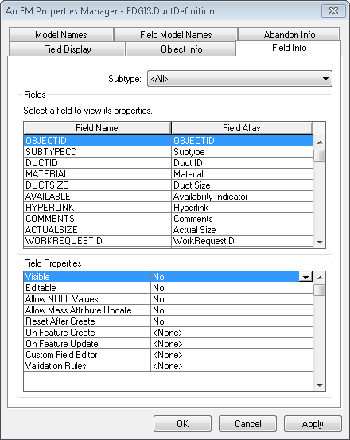
   2. SubtypeCD - change to not editable
   3. WorkRequestID - change to not visible
   4. DesignId - change to not visible
   5. WorkLocationID - change to not visible
   6. WorkFlowStatus - change to not visible
   7. WorkFunction - change to not visible
   8. ConduitSystemObjectID - change to not visible
   9. GlobalID - Ensure not visible
   10. DuctShape - change to visible
   11. Bypass - change to visible
   12. Condition - change to visible
   13. FiberOpticIdc - change to visible
   14. VentIdc - change to visible
   15. Misc1Idc – change to not visible
   16. Misc2Idc – change to not visible
   17. Misc3Idc – change to not visible
6. Select the Field Display tab.
7. Update the field order on the field display tab as follows:
   1. DuctID
   2. DuctSize
   3. ActualSize
   4. DuctShape
   5. Material
   6. Bypass
   7. Available
   8. Condition
   9. <Indicator fields including new ones>
   10. Hyperlink
   11. Comments  
       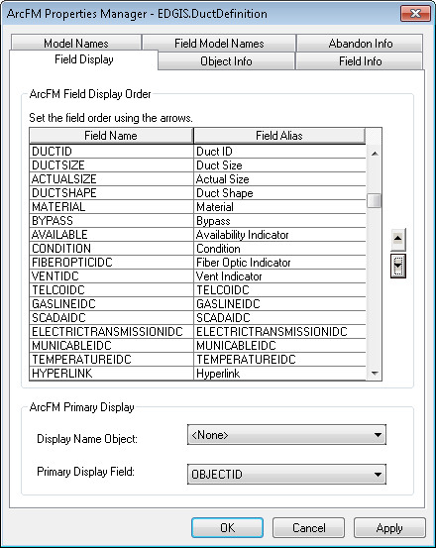

# 19360: New leader line subtypes for cross sections and butterfly diagrams

1. Get exclusive access of EDGIS
2. Navigate to EDGIS.ElectricDatase 🡪 EDGIS.LeaderLine; right click on it; select “Properties…”. Go To “Subtypes” tab.
3. Add two new subtypes, "Cross Section" and "Butterfly", to EDGIS.LeaderLine

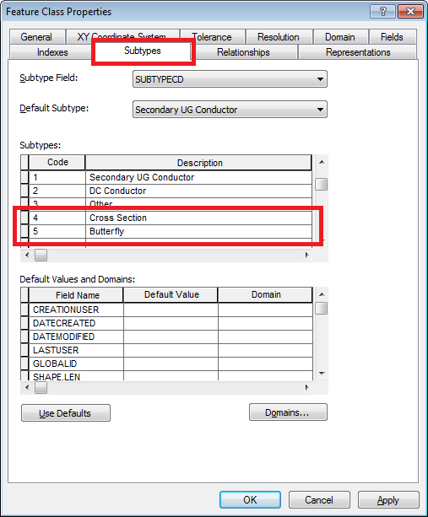

1. Click “Apply” button.
2. Go to “Fields” tab.
3. Add FacilityID field of type GUID

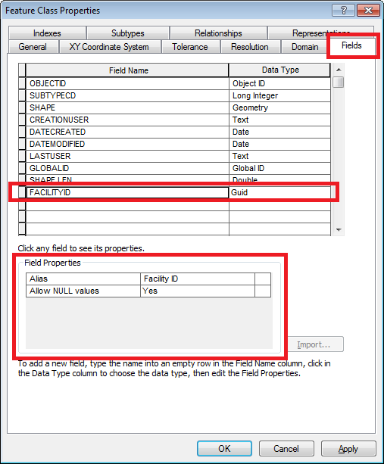

1. Click “Apply” button. Click OK.
2. Right click on EDGIS.LeaderLine. Select “ArcFM Properties Manager”. Go to “Field Info” tab.
3. Select “Primary UG Conductor” subtype from the dropdown.
4. Select Facility ID field. Set “Visible” property to “No”. Click Apply.

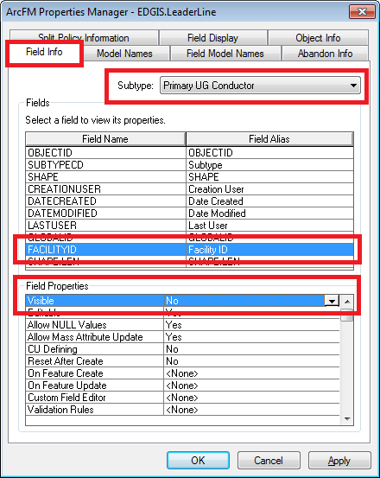

1. Repeat steps 9 and 10 (set “Visible” property of Facility ID field to “No”) for the following subtypes:

* Secondary UG Conductor
* DC Conductor
* Other
* Cross Section

1. Set “Visible” property of Facility ID field to “Yes” for the subtype – Butterfly

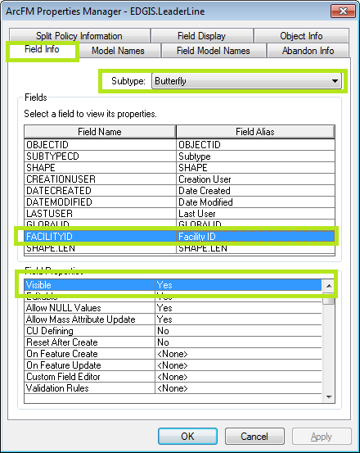

1. Go to “Object Info” tab. Assign the 'PGE Sync Facility IDs AU' to 'On Feature Create' for the Butterfly subtype.

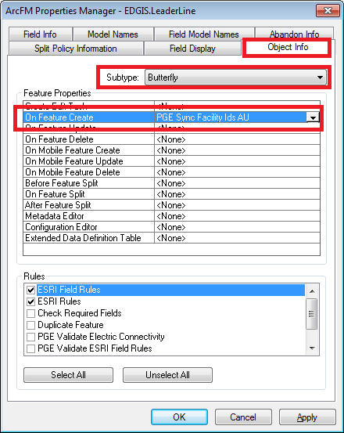

1. Go to the Field Model Names tab and assign the FACILITYID model name from the Electric Field Model Name domain to the new FACILITYID field.

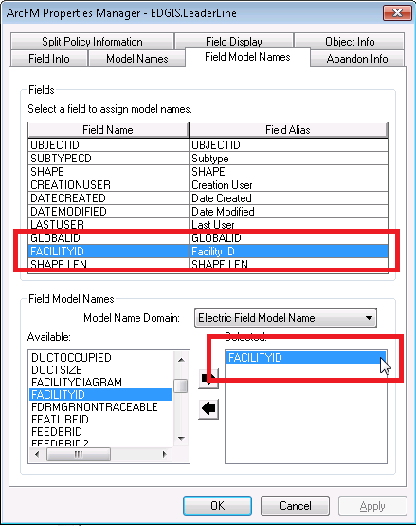

1. Click Apply. Click OK.

# 19607: Update ArcFM Properties

For each row in the attached spreadsheet where the **Action** column lists **Update**:

1. Right click on the feature class listed in the **ObjectClassRo** column and click **ArcFM Properties Manager**
2. Select the **Field Info** tab
3. Select the **Subtype** listed in column **SubtypeRo**
4. Navigate to the field listed in the **FieldRo** column
5. Update the field property referenced in column **Setting** to match the value in column **Prod 3 weeks ago (I1D)**
6. Click on **Apply**



Note: For field aliases, use the **Properties** right-click option in step 1 and the **Fields** tab in step 2

Note: For field indexes, use the **Field Display** tab in step 2 and use the arrow buttons to reorder the field in step 5

# 19654: Add new validation rule definitions to severity map

1. Open **SQL Plus**
2. Log in using the same server and as was used in section 2 but as user **sde**
3. Execute the following SQL:

insert into sde.telvent_validation_severitymap (objectid, name, severity) values (R657.nextval, 'PGE Validate UFM Conductor', 1);

insert into sde.telvent_validation_severitymap (objectid, name, severity) values (R657.nextval, 'PGE Validate Butterfly Diagrams', 1);

commit;

# 19858: Update PGE_CIRCUITCOLOR Table with New Circuits

1. Save the SQL script from the location in section 1.3 for circuit color documentation locally.
2. Open the script and change the spool location to the desired location.
3. In a command prompt, cd to the location of the saved SQL script.
4. Log into SQLPLUS as EDGIS.
5. Execute the script by issuing the following command:  
   @circuit_color_import.sql
6. Review the log file for errors.
7. Attach the log file to the TFS ticket.  
   Now we need to fix the sequence for the PGE_CIRCUITCOLOR table.
8. Execute the following statement:  
   SQL> select registration_id from sde.table_registry where table_name='PGE_CIRCUITCOLOR';

REGISTRATION_ID

---------------

682  
You will get the registration ID of the circuit color table.

1. Execute the following, replacing ‘682’ with the registration ID you received from the previous command.  
   SQL> select r682.nextval from dual;

NEXTVAL

----------

3276

1. Execute, with ‘1105’=4381-nextval:  
   SQL> alter sequence r682 increment by 1105;

Sequence altered.

1. Execute:  
   SQL> select r682.nextval from dual;

NEXTVAL

----------

4381

1. Execute:  
   SQL> alter sequence r682 increment by 1;

Sequence altered.

# 19840: Update Secondary UG Labeltext field length

1) Apply the instructions outlined in the attached document:



# 19941: Unversion the CommonFeaturesDataset dataset

1. In ArcCatalog, click Tools, then Customize.
2. Click the Commands tab in the Customize dialog box.
3. In the Categories list, click Geodatabase tools.
4. Click and drag the Unregister command from the Commands list and drop it onto the Standard toolbar.

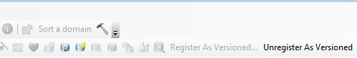

1. Click Close on the Customize dialog box.
2. Get the exclusive connection of EDGIS.
3. Select CommonFeaturesDataset at the root node.

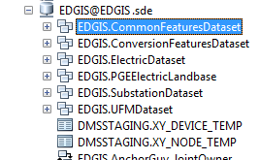

1. Click on the “Unregister As Versioned” command button.
2. Check the “Compress all edits in the Default version into the base table” checkbox.

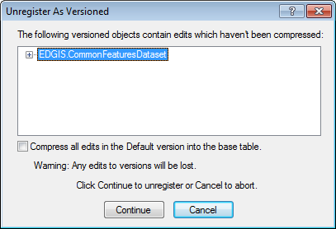

1. Click on “Continue” Button.
2. Click OK.

# Data Model Version Table

**Database Configuration:**

1. Open SQL Plus.
2. Log in using the same server and user as was used in section 2.  
     
   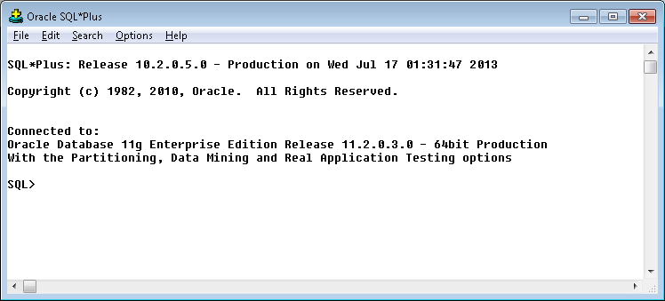
3. Run the SQL below:

update pgedatamodelversion set currentidc='N' where currentidc='Y';

insert into pgedatamodelversion (OBJECTID, CURRENTIDC, DATEAPPLIED, APPLIEDBYPERSONNAME, MODELVERSION) values (**INSERT NEXT VALID ID**,'Y',sysdate,'**<INSERT TEAM MEMBER DONE BY>**','**9.4** GOLD **TFS Ticket <INSERT TFS#>**');

commit;

# Known Issues

<Please List any other issues encountered here while following the document>